COMPUTATIONAL PRACTICUM assignment

Differential Equations

Artur Akhmetshin

Group: BS17-05

y’ = sin(x) + y

Exact solution of IVP(Initial Value Problem)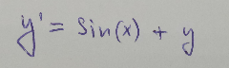

there x0 = 0 and y0 = 1

Given Differential Equation:

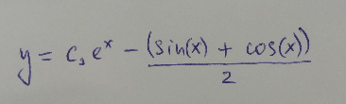  
  
  
Solution of DE:

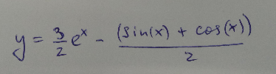  
  
  
Solution of IVP:

There isn’t any point of discontinuity in solution of given differential equation.